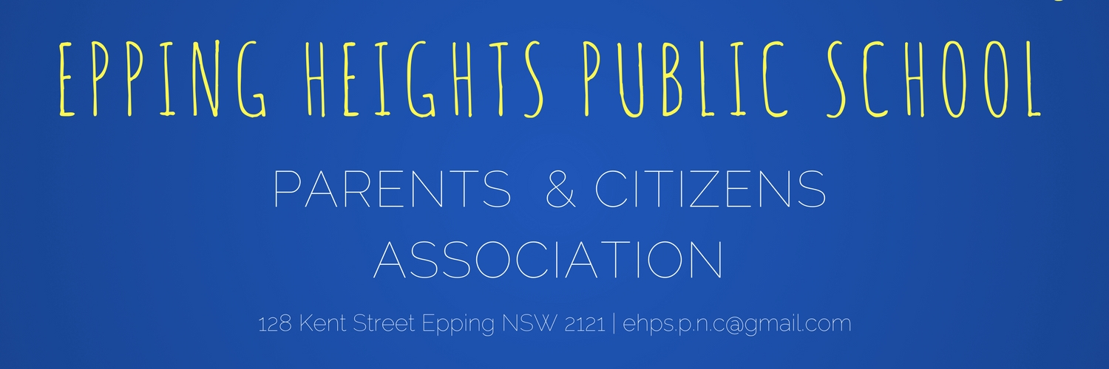
EHPS UNIFORM INFORMATION
BOYS SUMMER UNIFORM (worn Terms 1 and 4)
Boys wear the same navy shorts and EHPS polo 5 days/week.
School uniform 3-4 days/week: Navy shorts with EHPS polo shirt with NAVY SOCKS/BLACK LEATHER SCHOOL SHOES
Sport uniform 1-2 days/week: Navy shorts with EHPS polo shirt with WHITE SPORT SOCKS AND SPORT SHOES (ANY)
GIRLS SUMMER UNIFORM (worn Terms 1 and 4)
School uniform 3-4 days/week: Summer dress OR tailored short with polo shirt with NAVY SOCKS/BLACK LEATHER SCHOOL SHOES.
Sport uniform 1-2 days/week: Navy skort with EHPS polo shirt with WHITE SPORT SOCKS AND SPORT SHOES (ANY)
Winter Uniform is generally purchased toward the end of term 1 and is worn in Terms 2 and 3.
BOYS WINTER UNIFORM (worn in Terms 2 and 3)
School uniform 3-4 days/week: Navy trousers and EHPS long sleeve polo with NAVY SOCKS/BLACK LEATHER SCHOOL SHOES
Sport Uniform 1-2 days/week: Navy trackpants (or shorts) with EHPS long sleeve polo with WHITE SPORT SOCKS AND SPORT SHOES (ANY)
GIRLS WINTER UNIFORM
School uniform 3-4 days/week: Navy check tunic with EHPS long sleeve polo underneath OR Navy bootleg pant with EHPS long sleeve polo with NAVY SOCKS or TIGHTS and BLACK LEATHER SCHOOL SHOES
Sport uniform 1-2 days/week: Navy bootleg pant (or skort) with EHPS long sleeve polo shirt with WHITE SPORT SOCKS AND SPORT SHOES (ANY)
STARTER PACK
We offer a starter pack option for boys and girls starting kindergarten or for students new to the school. The pack includes the school backpack as well as the minimum of uniform essentials most people have found they need. A free library bag is provided if you purchase the starter pack. You may also wish to purchase additional items (eg. a second dress) which you are welcome to do at the same time, or once your child has started school and you are clearer on what your requirements are. The uniform shop delivers orders to students in their classroom approx. once per week throughout school terms
Boys Starter pack – 2 x EHPS s/s polo, 2 x Navy Short, 1 x Jacket, 1 x Hat, 1 x Backpack, 1 x free library bag
Girls Starter pack – 1 x dress, 1 x skort, 1 x EHPS s/s polo, 1 x jacket, 1 x Hat, 1 x Backpack, 1 x free library bag
SIZING - Most kindy children wear a size 4 or 6 to start their school life. For petite/slight to average children, size 4 is usually large enough. For exceptionally tall/broader children, a size 6 may be required. See Uniform size guide.
Most uniforms are available in sizes 4, 6, 8, 10 and so on up to 16. These sizes correspond ROUGHLY to age but we have a EHPS Uniform Size Guide that you may like to refer to when ordering uniforms if unfamiliar with the sizing. Please see below for some extra information about certain items:
GIRLS SUMMER DRESS - The sizing is large on this dress so most smaller girls will wear a size 2 (equiv. to a normal 4) and others a 4 (equiv. to a 6). See size guide.
HATS - For sun safety, the school adopts a ‘no hat, no play’ policy. Approx. dimensions given. Note that girls who wear a ponytail/pigtails often purchase a size up. PLEASE ENSURE YOUR CHILDS NAME IS WRITTEN INSIDE HAT IN MARKER IN LARGE LETTERS.
SOCKS - The size is according to shoe size – S shoe size 9-12 (most kindys), M shoe size 13-3, L shoe size 2-8 (or 4-10 in women’s sizing)
JACKETS - Although the start of the school year is in summer, it is wise to purchase a jacket in case of cool mornings etc. PLEASE ENSURE YOU LABEL JACKETS CLEARLY WITH CHILDS NAME AND CHECK PERIODICALLY TO MAKE SURE IT IS STILL LEGIBLE. LOST JACKETS ARE COSTLY TO REPLACE.
VESTS – These are an optional item – some find them useful in the in between season when a jacket is a bit too much. They are a much smaller, slimmer fit than the jacket so if ordering, please check measurements and order 1 or 2 sizes larger than you normally would for other items.
SCHOOL BACKPACK - The EHPS backpack is not compulsory but it has been chosen because of its suitability and durability. If your child wishes to use their own backpack, please ensure that it is large enough to pack everything into easily and also easy to open/close.
ART SMOCK - You will be asked by your child’s teacher to provide an art smock/cover up sometime early in term 1. It does not have to be the one we sell – any suitable item is fine. Again, please make sure it is labelled. The one we stock is water resistant and sized so it will fit for many years.

